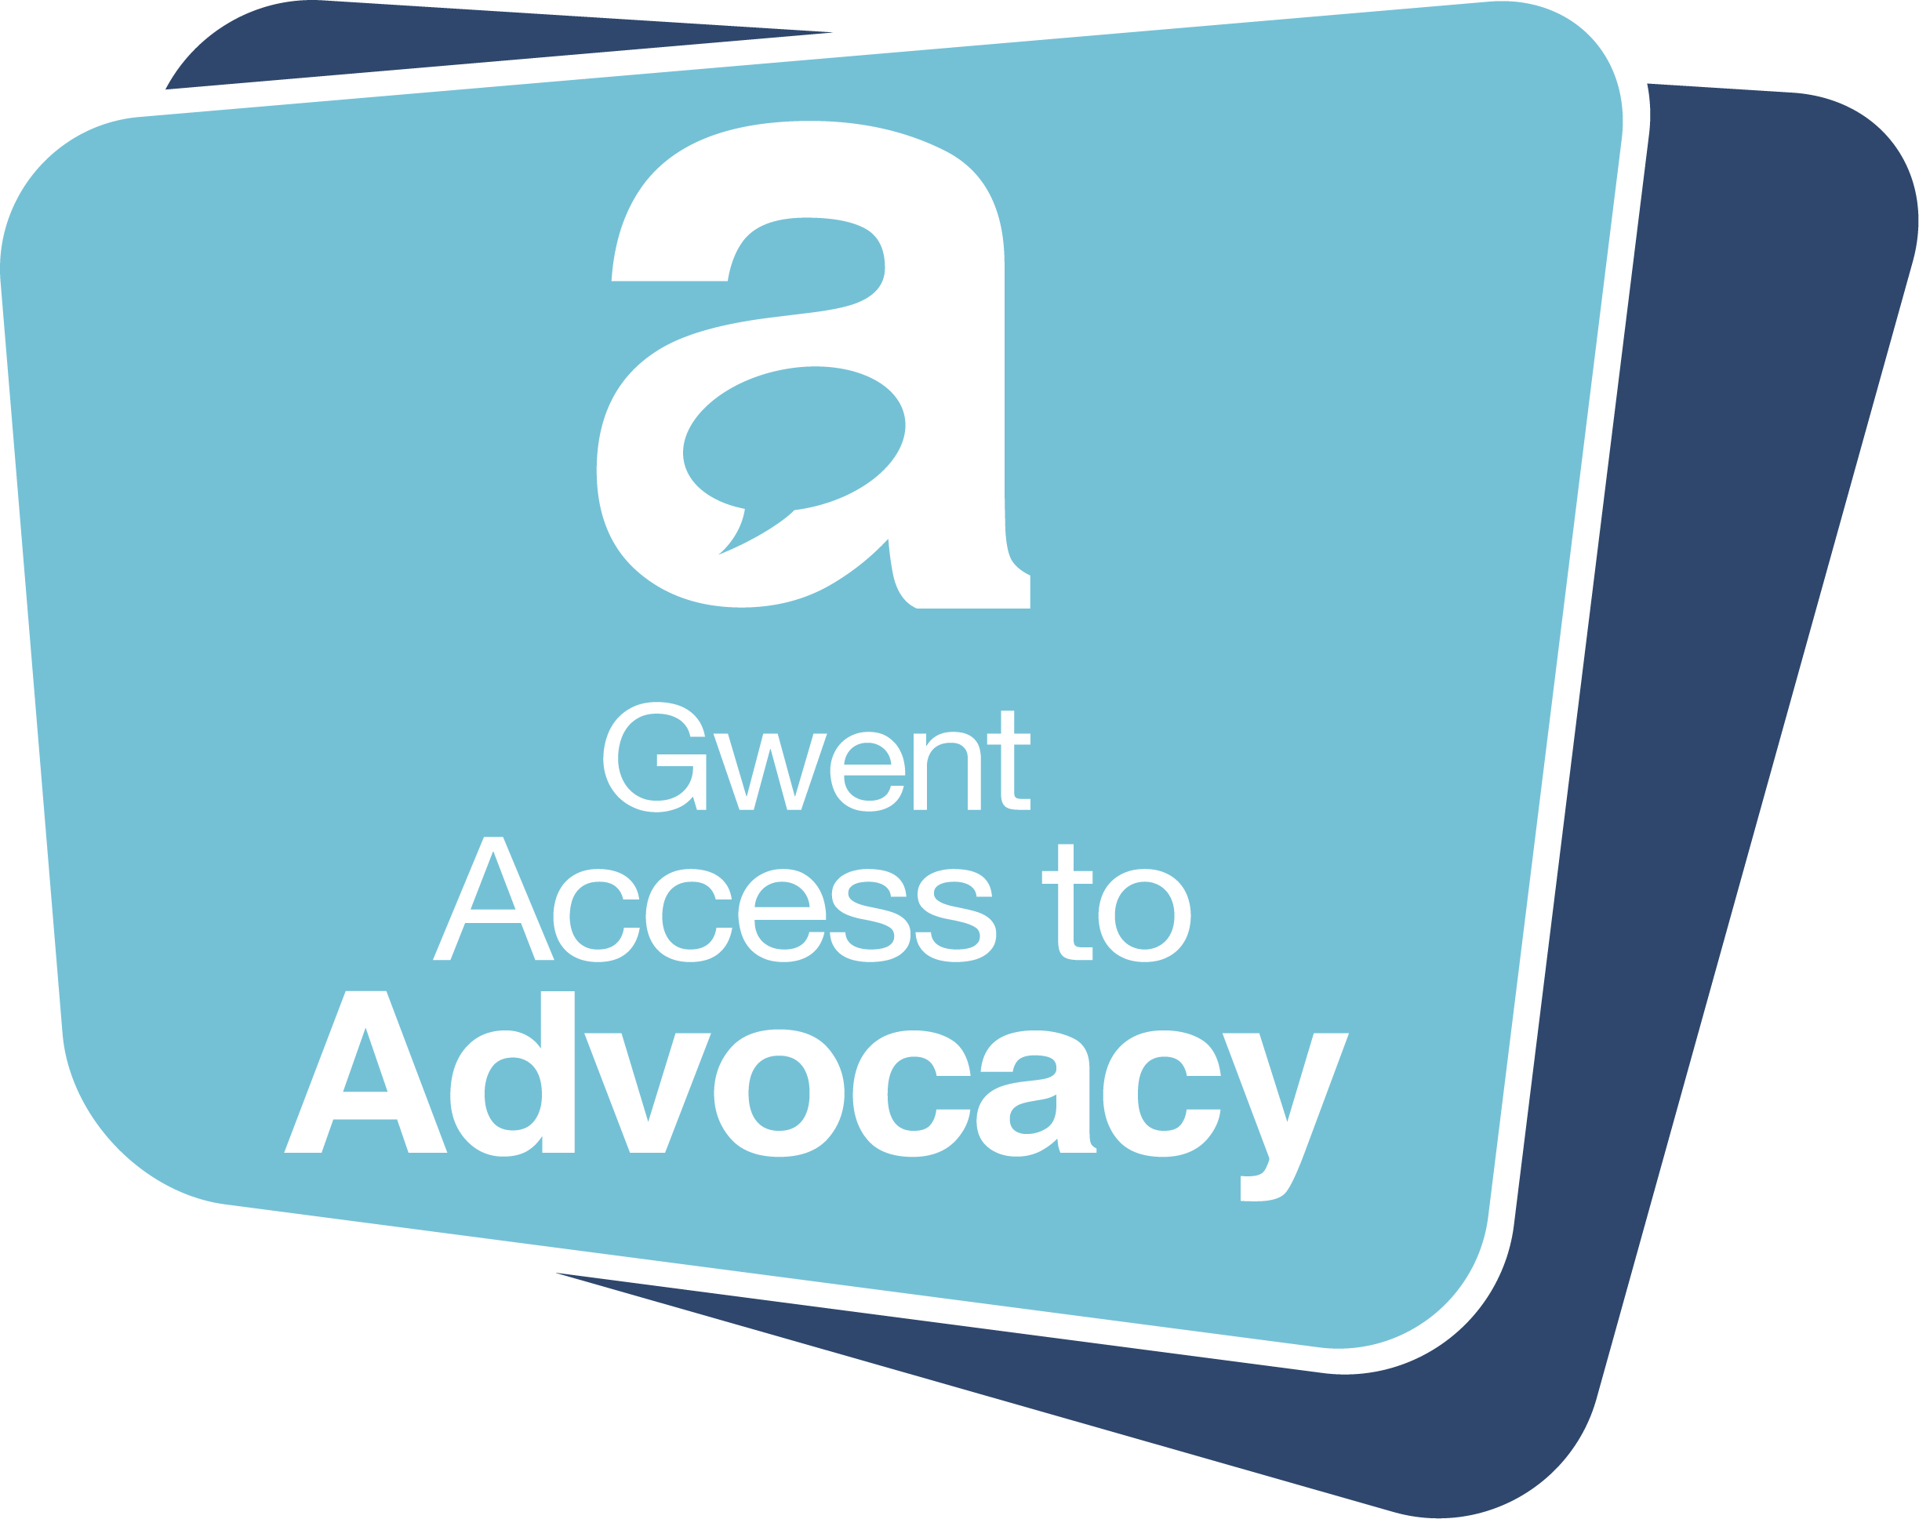
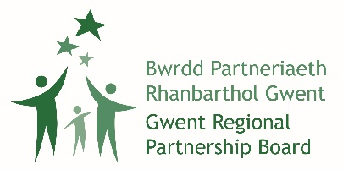

GATA - A new advocacy service helpline for Gwent
ProMo-Cymru has developed a new advocacy service helpline to support citizens living in Gwent (Torfaen, Blaenau Gwent, Caerphilly and Monmouthshire) to have a voice and a choice when it comes to social care support services, particularly as defined by the Social Services and Well-being(Wales) Act (2014). Newport citizens can continue to access Dewis Centre for Independent Living for advocacy and advice.
Introducing Gwent Access to Advocacy (GATA)
Intended to be the first port of call, this free telephone helpline can be contacted on 0808 8010566 for advocacy-related information, advice and assistance. GATA is open Monday to Friday, 10am to 3pm. It is staffed by a highly skilled professional team of Helpline Advisor Advocates.
The service is available to Gwent residents aged over 18 who may need help to have their views heard, understand their options in relation to social care and support services they are receiving, or think they may need, and / or exercise more control over decisions that are being made about their social care and support. Carers and practitioners can also contact the service.
Led by the Gwent Regional Partnership Board, with support from Age Cymru’s Golden Thread Advocacy Programme, there has been a fully co-productive approach to developing this helpline.
Other important partners in this development are Age Cymru Gwent, Dewis Cil, Training in Mind, NYAS Caerphilly and the People First organisations within each Local Authority area.
Phil Robson, Chair of the Gwent Regional Partnership Board said: “Making sure that all our citizens are able to make their voices heard is vitally important if we are to truly transform and improve our health and social care services to be fit for the twenty first century. We know that the care system can be overly complex and not always easy for citizens to find and access the information and support that can best help them. Advocacy has an important part to play in making sure that all voices are heard – and we recognize that this is an important service that needs to be available equitably, where and when needed.”
How GATA helps
The Helpline team can help:
- Establish what matters and is important to the caller. Make sense of their situation and their needs. Explore options regarding any identified social care/support needs.
- Access and understand information that is relevant to their situation. Understand how to navigate any planning, review and decision-making processes.
- Reach the most appropriate destination as quickly and efficiently as possible, whether through direct representation or referral/signposting to face to face independent professional advocacy, other advocacy, or other support services.
The benefits
The model and pathway are unique; in addition to helping the individual concerned, there are other benefits too:
- Promote a better and wider understanding of advocacy
- Engage with a wider audience resulting in a wider take up of advocacy where needed
- Facilitate collaborative working and networking among advocacy service providers
Stephanie Hoffman, Head of Social Action at ProMo-Cymru, said; “Our expertise in developing and delivering online and digital information, advice, assistance and advocacy services, along with our reputation in valuing people’s rights, made us the perfect choice to develop and deliver this new service to benefit the citizens of Gwent.”
Further information and printed materials
If you would like further information or would like to request printed materials on Gwent Access to Advocacy (GATA), please visit www.gata.cymru, e-mail socialaction@promo.cymru or call ProMo-Cymru on 02920 462 222.
The Gwent Advocacy for Adults Strategy can be downloaded here.

#END#
(WELSH BELOW)

MIEG - Llinell gymorth gwasanaeth eiriolaeth newydd Gwent
Mae ProMo-Cymru wedi datblygu llinell gymorth gwasanaeth eiriolaeth newydd sydd yn cefnogi trigolion Gwent (Torfaen, Blaenau Gwent, Caerffili a Sir Fynwy) i gael llais a dewis pan ddaw at wasanaethau cefnogol gofal cymdeithasol, sydd yn cael eu diffinio gan y Ddeddf Gwasanaethau Cymdeithasol a Llesiant (2014) yn arbennig. Mae trigolion Casnewydd yn gallu parhau i ddefnyddio Canolfan Byw'n Annibynnol Dewis am eiriolaeth a chyngor.
Cyflwyno Mynediad i Eiriolaeth Gwent (MIEG)
Ei fwriad yw bod yn borth galw cyntaf. Gellir cysylltu â'r llinell gymorth am ddim yma ar 0808 8010566 am wybodaeth, cyngor a chymorth yn ymwneud ag eiriolaeth. Mae MIEG yn agored Llun i Gwener, 10yb tan 3yp. Mae'n cael ei staffio gan dîm proffesiynol o Eiriolwyr Gynghorwyr Llinell Gymorth medrus iawn.
Mae'r gwasanaeth yn agored i drigolion dros 18 oed yng Ngwent sydd angen cymorth i gael pobl i glywed eu barn, deall eu hopsiynau pan ddaw at y gwasanaethau cymorth a'r gofal cymdeithasol derbyniwyd, neu'n meddwl eu bod angen ac/neu eisiau mwy o reolaeth dros y penderfyniadau am eu gofal cymdeithasol a chymorth. Mae gofalwyr ac ymarferwyr yn gallu cysylltu â'r gwasanaeth hefyd.
Yn cael ei arwain gan Fwrdd Partneriaeth Ranbarthol Gwent, gyda chefnogaeth Rhaglen Eiriolaeth Edau Aur Age Cymru, rydym wedi defnyddio dull cwbl cyd-gynhyrchiol wrth ddatblygu'r llinell gymorth yma.
Mae Age Cymru Gwent, Dewis CIL, Hyfforddiant Mewn Meddwl, NYAS Caerffili a'r sefydliadau Pobl yn Gyntaf ymhob Awdurdod Lleol, wedi bod yn bartneriaid pwysig yn y datblygiad yma.
Dywedodd Phil Robson, Cadeirydd Bwrdd Partneriaeth Ranbarthol Gwent: "Mae sicrhau bod pob trigolyn yn cael ei glywed yn hynod bwysig os ydym o ddifrif am drawsffurfio a gwella ein gwasanaethau iechyd a gofal cymdeithasol fel ei fod yn addas ar gyfer yr unfed ar hugain ganrif. Rydym yn ymwybodol bod y system gofal yn gallu bod yn orgymhleth ac nid yw'n hawdd iawn i drigolyn ddarganfod a chael mynediad i'r wybodaeth a'r gefnogaeth gall ei helpu orau bob tro. Mae gan eiriolaeth ran bwysig iawn i chwarae i sicrhau bod pob llais yn cael ei glywed - ac rydym yn cydnabod bod hwn yn wasanaeth pwysig sydd angen bod yn agored i bawb, ymhle a pan fydd ei angen."
Sut bydd MIEG yn helpu
Gall y tîm Llinell Gymorth helpu i:
- Deall yr hyn sydd yn bwysig i'r galwr. Gwneud synnwyr o'u sefyllfa a'u hanghenion. Archwilio'r opsiynau pan ddaw at unrhyw anghenion gofal cymdeithasol/cefnogaeth sydd yn cael ei adnabod.
- Mynediad i, a deall, unrhyw wybodaeth sydd yn berthnasol i'w sefyllfa. Deall sut i lywio unrhyw brosesau cynllunio, adolygu a gwneud penderfyniadau.
- Cyrraedd y cyrchfan fwyaf addas mor sydyn ac effeithiol â phosib, bod hyn drwy gynrychiolaeth uniongyrchol neu gyfeirio/arwyddbostio i eiriolaeth broffesiynol annibynnol wyneb i wyneb, eiriolaeth arall, neu wasanaethau cefnogol eraill.
Y buddiannau
Mae'r fodel a'r llwybr yn unigryw; yn ogystal â helpu'r unigolyn, mae yn fuddiannau eraill hefyd:
- Hyrwyddo dealltwriaeth eiriolaeth well a fwy eang
- Cysylltu gyda chynulleidfa ehangach sydd yn golygu bod mwy o bobl yn derbyn eiriolaeth pan fydd angen
- Hwyluso gweithio ar y cyd a rhwydweithio ymysg darparwyr gwasanaethau eiriolaeth
Dywedodd Stephanie Hoffman, Pennaeth Gweithredu Cymdeithasol ProMo-Cymru: "Mae ein profiad yn datblygu a chyflwyno gwasanaethau gwybodaeth, cyngor, cymorth ac eiriolaeth ar-lein a digidol, ynghyd â'n henw da yn gwerthfawrogi hawliau pobl, yn golygu ein bod yn ddewis perffaith i ddatblygu a chyflwyno'r gwasanaeth newydd yma er budd trigolion Gwent."
Gwybodaeth bellach a deunyddiau argraffedig
Os hoffech fanylion pellach neu os hoffech wneud cais am ddeunyddiau argraffedig Mynediad i Eiriolaeth Gwent (MIEG), ymwelwch â www.mieg.cymru, e-bost socialaction@promo.cymru neu galwch ProMo-Cymru ar 02920 462 222.
Gellir lawr lwytho Strategaeth Eiriolaeth i Oedolion yng Ngwent yma.

#DIWEDD#

