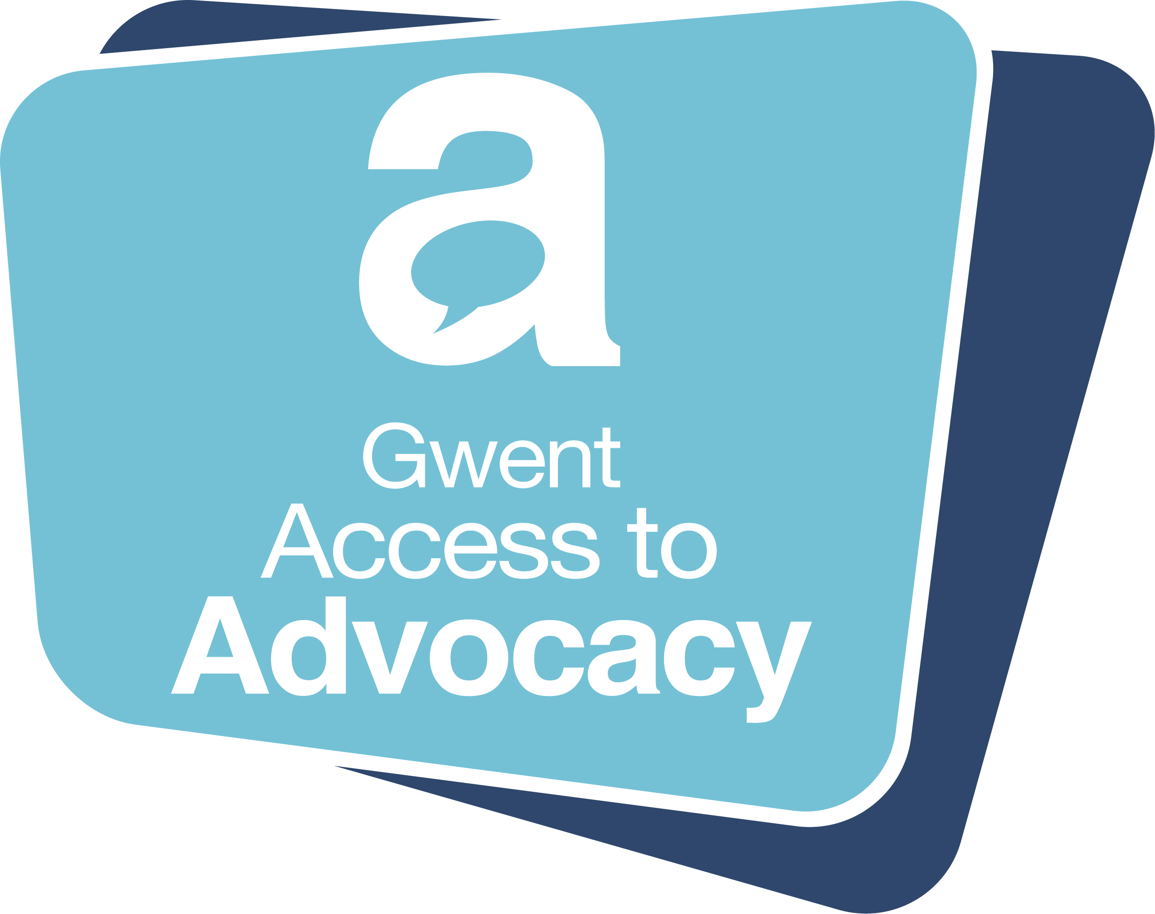

Social Care Triage Aide Memoire

Introduction and Instructions:

This form serves a dual purpose: i) as an aide memoire for triaging, and ii) to facilitate referral to Gwent Access to Advocacy (GATA) in order to access advocacy.

It is intended to elicit the basic information required to establish entitlement to advocacy, whether this is statutory independent professional advocacy (IPA), non-statutory IPA or other forms of advocacy. Please note that any other form of support must be directed to local Information Advice and Assistance (IAA) teams or community hubs.

If you wish to make a referral for advocacy, please contact the helpline Monday – Friday 10am – 3pm on 0808 801 0566 to pass on the relevant information to an Adviser.

If you have any questions, are unable to provide all the information required, or there are headings which are not applicable, please contact the helpline Monday – Friday 10am – 3pm on 0808 801 0566 to speak to an Adviser.

1. Referrer Details

Name / Designation / Team
Telephone / Mobile
Email
Date of referral

2. Citizen Details

Name
Telephone / Mobile
Email
Permanent Address
Current Address (if different)
The citizen is aware of this referral: Yes / No
The citizen consents to sharing and disclosure of personal information on their behalf for the purpose of accessing advocacy: Yes / No
GATA is able to contact the citizen directly: Yes / No

Issue requiring advocacy ie: views / wishes / feelings to be conveyed

What outcome do they wish to achieve

3. Social Care Pathway stage:

Assessment
Care planning
Care Review
Safeguarding
Discharge / Closure / Transfer
Other (eg: social welfare such as benefits and / or housing issues, parent with PR of children) going through child protection / PLO – please specify)
Not applicable

Meetings (dates, name, status) coming up where advocacy representation required

4. Suitable / Appropriate / Available individual to act as advocate

Confirm that you have discussed in partnership with the person whether there is an Appropriate Individual who is suitable and available, and whom they are content to act on their behalf.

5. Communication barriers

Accessing information
Retaining / Remembering information
Understanding information
Able to use / weigh information
Able to articulate and express views, wishes and feelings
None of the above

Reason / cause (eg: cognitive impairment, vulnerability, dementia)

6. Other (statutory) entitlement

Capacity / IMCA

Under care of secondary mental health services / IMHA / Community Advocacy

Diagnosed learning disability – details: (e.g. autism/ aspergers)

Note:

On receipt of contact, and if relevant, Adviser will open case, enter details on to secure database, and issue case number which will be used for reference, action, and follow up purposes.

END

